H.T No
Regulations:
A18

Sreenidhi Institute of Science and Technology
(An Autonomous Institution)
Code No: 7EC67 Date: 08-Jan-2025 (FN)

B.Tech IV-Year I- Semester External Examination, Dec/Jan - 2024/25 (Supplementary)
OPERATING SYSTEMS CONCEPTS - (OE-III) (ECE)

Time: 3 Hours Max.Marks:70

Note: a) No additional answer sheets will be provided.
b) All sub-parts of a question must be answered at one place only, otherwise it will not be valued.
c) Missing data can be assumed suitably.

Bloom's Cognitive Levels of Learning (BCLL)

Remember | L1 | Apply | L3 | Evaluate | L5
Understand | L2 | Analyze | L4 | Create | L6

Part - A Max.Marks:20
Answer all QUESTIONS

 |  | BCLL | CO(s) | Marks
1 | List any four services of operating system. | L1 | CO1 | [2M]
2 | Write the various states of a process. | L1 | CO2 | [2M]
3 | Write any two classical problems of Synchronization. | L1 | CO3 | [2M]
4 | Define deadlock. | L1 | CO4 | [2M]
5 | List out all the page replacement algorithms. | L1 | CO5 | [2M]
6 | List any four common file types and their extensions. | L1 | CO6 | [2M]
7 | Define Throughput. | L1 | CO2 | [2M]
8 | Define Safe state and unsafe state. | L1 | CO3 | [2M]
9 | Define Thrashing. | L1 | CO5 | [2M]
10 | List the different types of Multiprocessing. | L1 | CO6 | [2M]
Part – B Max.Marks:50
ANSWER ANY FIVE QUESTIONS. EACH QUESTION CARRIES 10 MARKS.

 |  |  | BCLL | CO(s) | Marks
11. | a) | Explain different types of system calls with suitable example. | L2 | CO1 | [5M]
 | b) | Explain briefly about Layered Operating system structure. | L2 | CO1 | [5M]
12. |  | - Consider the following four processes, with the length of the CPU burst time given in milliseconds.  - 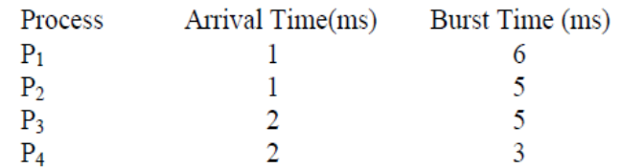  Compute Average Waiting Time and Turnaround time for given Process using FCFS and SJF Algorithms Draw the Gantt Chart as well. | L3 | CO2 | [10M]
13. |  | Define Semaphore? Explain how can we achieve the synchronization using semaphore for producer consumer problem. | L3 | CO3 | [10M]
14. |  | What is Resource-Allocation Graph? Explain Resource - Allocation Graph algorithm to avoid Deadlock with suitable example. | L3 | CO4 | [10M]
15. | a) | Explain about contiguous memory allocation. | L2 | CO5 | [5M]
 | b) | What is demand paging? Explain. | L2 | CO5 | [5M]
16. |  | Explain Various File Allocation methods in detail. | L2 | CO6 | [10M]
17. | a) | Explain the objectives and functions of Operating system. | L2 | CO1 | [4M]
 | b) | Explain different Process states with a neat diagram. | L2 | CO2 | [3M]
 | c) | Write short notes on message passing. | L2 | CO3 | [3M]
18. | a) | Explain four necessary conditions to be hold simultaneously to enter the system into Deadlock. | L1 | CO4 | [4M]
 | b) | Discuss about Demand paging. | L2 | CO5 | [3M]
 | c) | Write short notes on Free space Management. | L2 | CO6 | [3M]

-- 00 -- 00 –

